**West Coast Collaborative**

**Specialist Mathematics Units 3 & 4**

**Investigation 2 2017**

**A Vector Approach to Closest Approach in 3D**

**Take Home Section – due Tuesday 25 April**

**Complete this Take Home Component on file paper showing all working out and reasoning. Use of CAS calculator to aid calculation is assumed. On completion of Part 1 there will be a Validation Task (Part 2). For Part 2, CAS calculators will be allowed but no other notes will be permitted.**

**Part 1: Take Home Component**

**1.**

**Distance between a point and line using the Scalar Product method.**

Find the shortest distance from point to the line .

Minimum distance occurs when is perpendicular to line.



Hence,  is perpendicular to vector 

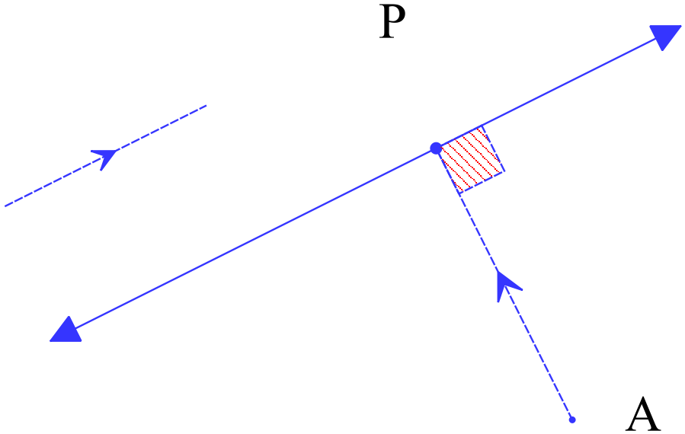

Since,





As  is perpendicular to vector 

   



= 

Therefore,



**2.**

The position vectors (**r**) and velocity vectors (**v**) of two ships A and B at 9.00 a.m. on a particular day were as follows:

At 9.00 a.m.

 km  km/h.

 km  km/h.

Show that if the two ships continue with these velocity vectors they will collide.

Solution

If *t* is the number of hours after 9 a.m. then

At *t* hours past 9 a.m. the respective positions of A and B will be   
  

 

Position vectors of A and B will have same **i** component when

i.e. when 

Position vectors of A and B will have same **j** component when

i.e. when 

The same **i** component of position vector occurs at 2.00 p.m. and also the same **j** component occurs at 2.00 p.m. Thus A and B collide at 2.00 p.m.

The position vectors (**r**) and velocity vectors (**v**) of two ships A and B at 9.00 a.m. on a particular day were as follows:

At 9.00 a.m.

 km  km/h.

 km  km/h.

3.

Show that if the two ships continue with these velocity vectors their *paths will cross* but they will *not collide*.

Solution

If *t* is the number of hours after 9 a.m. for ship A andis the number of hours after 9 a.m. for ship B. (Why different time values?)

at *t* hours past 9 a.m. the position of A will be   
  

at hours past 9 a.m. the position of B will be

 

Position vectors of A and B will have same **i** component when

i.e. when 

Position vectors of A and B will have same **j** component when

i.e. when 



As the times are different it suggests that the two ships will be in the same place at the *differing* times. Hence, no collision but their paths will cross at the point:

For 

For 

Hence, we will be in the same palace at different times. Hence, no collision occurs.

4.

**Example**

Particle P starts moving from a point with position vector < 10, 14 > metres with constant velocitie < 5, 2 > metres per second. P continues with this velocity passing a stationary object at A< 34,12 > metres. Find the closest distance between P and A. State where and when this occurs.

**Solution**:   
Assume that P is closest to A at time *t*.

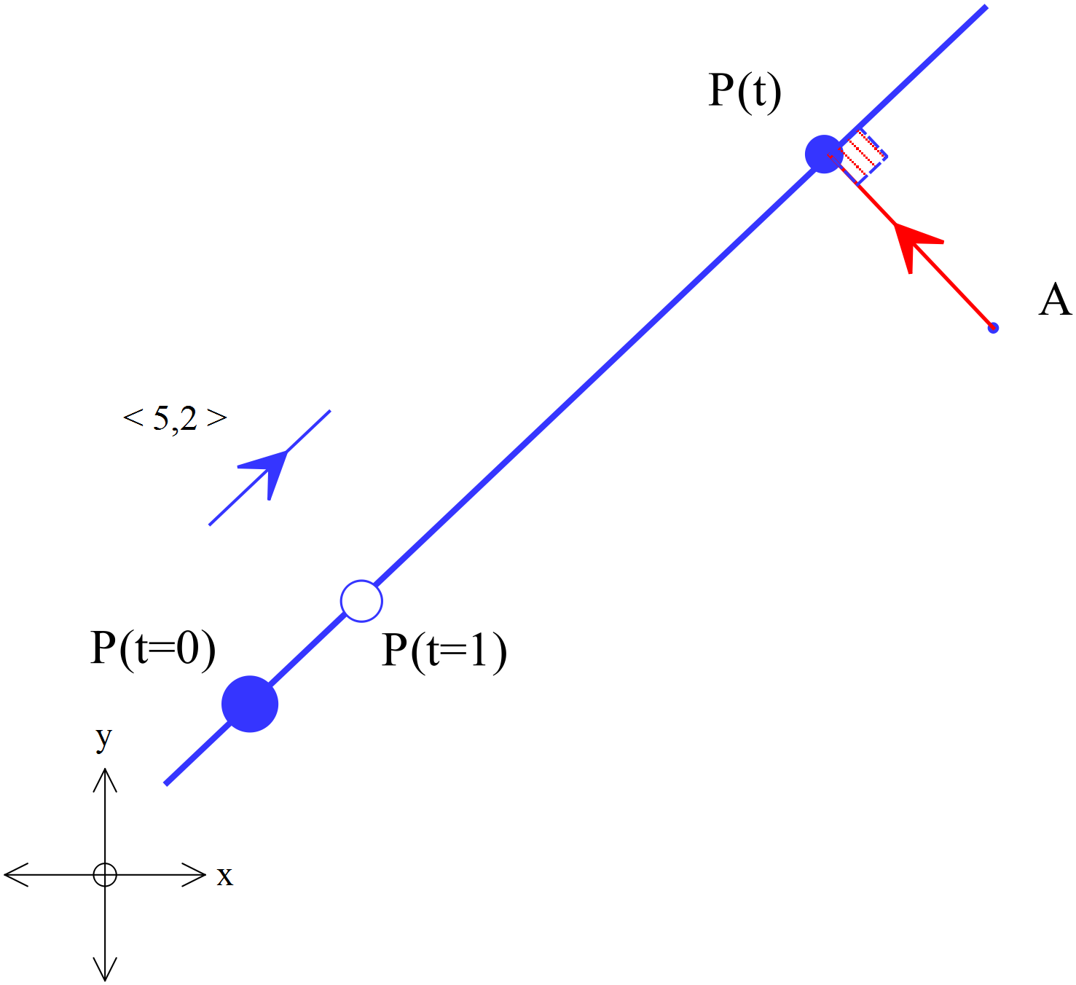

Velocity vector of P at time *t* is

Position vector of P at time *t* is    
  
Position vector of A at time *t* is 

Position of **P relative to** A at time *t*,   
P will be closest when vector AP is perpendicular to the line!

At closest approach when   
  
Position of **P relative to A** at time , 

Closest distance is the length of the vector



Hence, closest distance between P and A is  m.

**Validation Exercise**

**Problem**

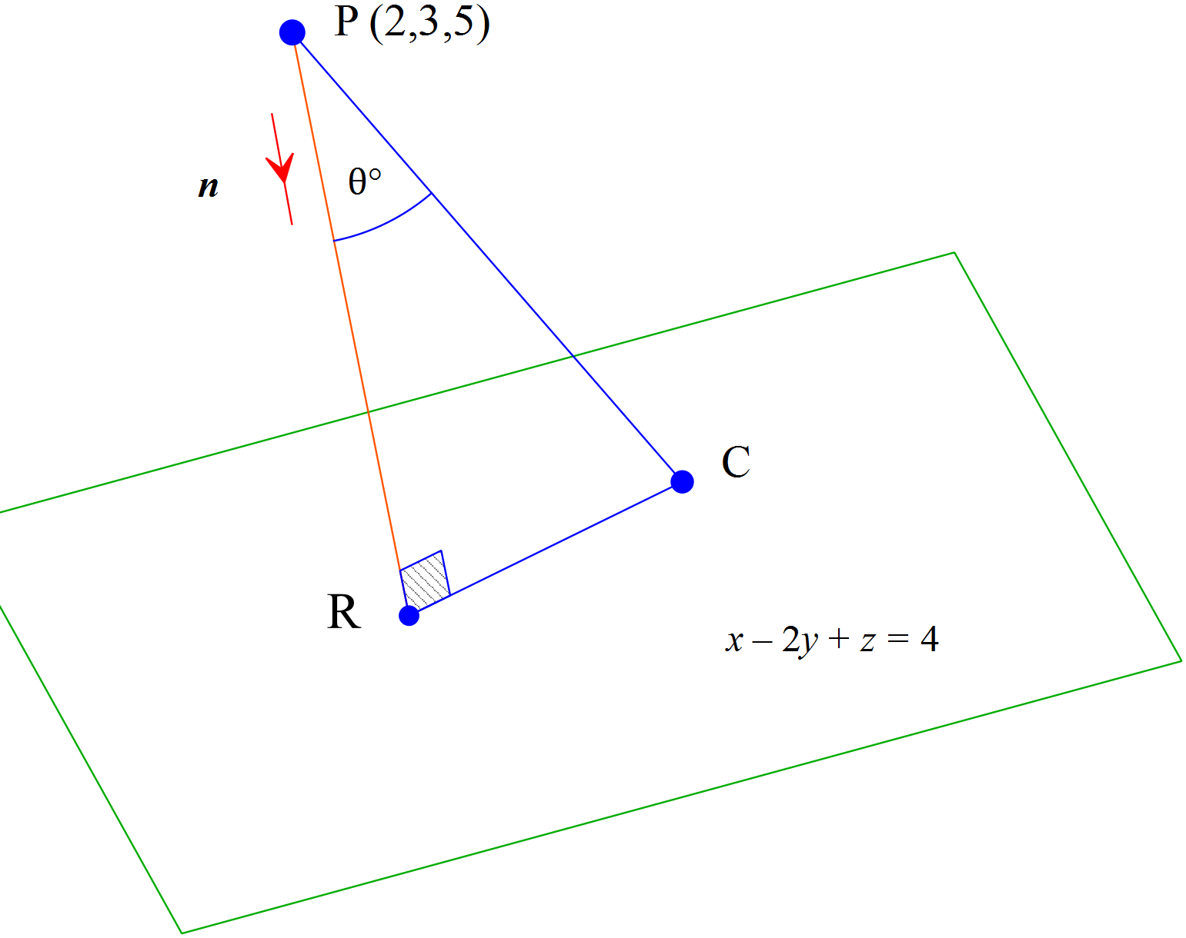

Find the distance from point P (2,3,5) to the plane with vector equation.

**Solution**

Step One

Find just one point on the plane. e.g. C is (3,1,3) because



Hence 

Step Two

Find the ***unit*** *vector normal* to the plane, using a cross product

As and are parallel to the plane it follows that a vector normal to the plane is



As is normal to the plane the ***unit*** normal will be:

Since where is a *unit* *normal* vector.

Hence,



**Distance from a point to a plane (alternative method i)**

Determine the shortest distance from the point to the plane .

Let B(a, b, c) be on the plane such that  is perpendicular to the plane. i.e  will be the minimum distance.

Equation of line through A and perpendicular to plane is

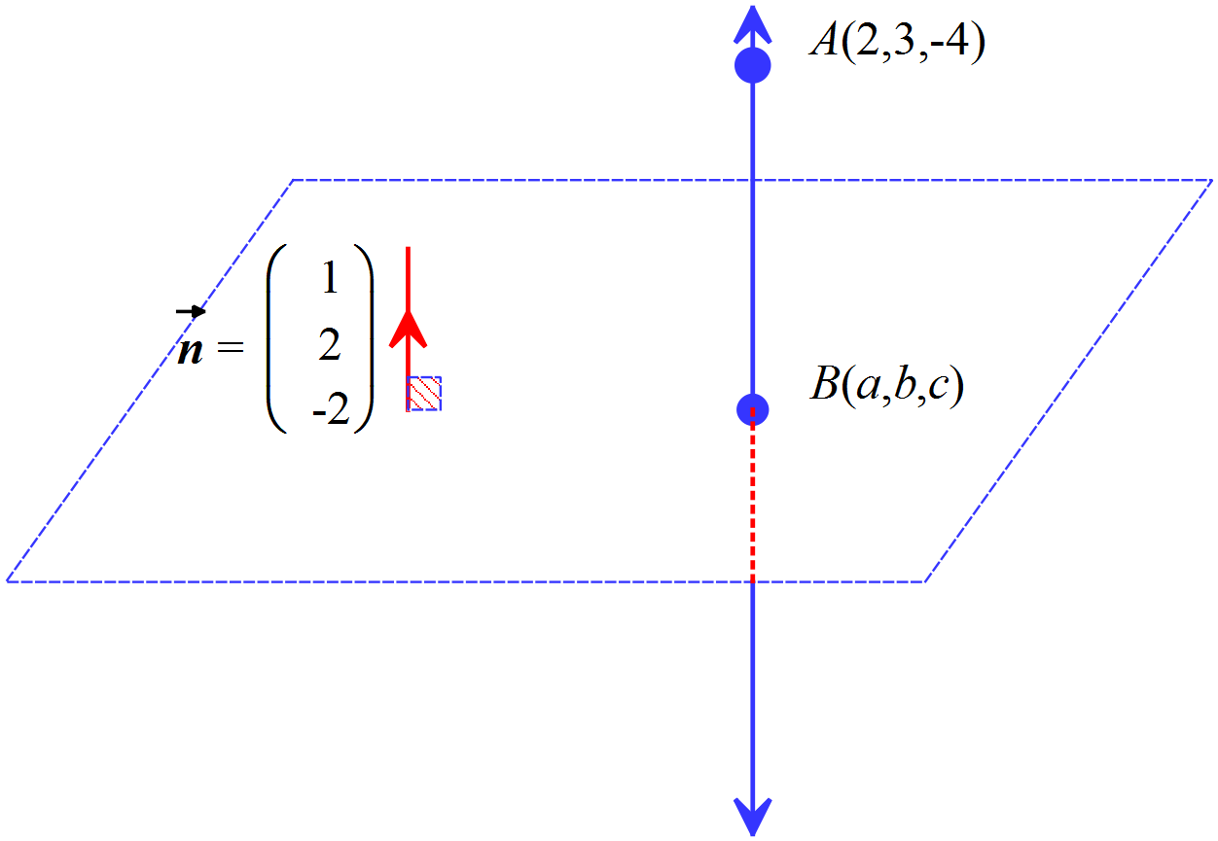





At point of intersection B

 

2 + λ + 6 + 4λ + 8 + 4λ = 7

λ = −1

So for λ = −1, B = =

Therefore  = 

 

**Distance from a point to a plane (alternative method ii)**

Determine the shortest distance from the point to the plane .

Let B(a, b, c) be on the plane such that  is perpendicular to the plane. i.e  will be the minimum distance.



 = $\left(\begin{aligned}a-2 \\ b-3 \\ c+ 4\end{aligned}\right)$



 $\left(\begin{aligned}1 \\ 2 \\ -2\end{aligned}\right)$ (normal to the plane.)

$\left(\begin{aligned}a-2 \\ b-3 \\ c+ 4\end{aligned}\right)$ =*k $\left(\begin{aligned}1 \\ 2 \\ -2\end{aligned}\right)$*

*So a* − 2 = *k*, b − 3 = 2*k*, c + 4 = −2*k*

Also $\left(\begin{aligned}a \\ b \\ c\end{aligned}\right)$ $\left(\begin{aligned}1 \\ 2 \\ -2\end{aligned}\right) = 7$

*a* + 2*b* − 2*c* = 7 (1.2)

Substituting equations from (1.1) into (1.2)

2 + *k* + 2(3 + 2*k*) − 2(− 4 − 2*k*) = 7

*k* = −1

Therefore  = −1 

 = $\sqrt{1+4+4}$ = 3 units